Tec.Nano 2019
Exploring the effect of Mechanical Compressive Treatment in Electrical Conductivity of SU-8-based Carbon Structures
Saeed Beigi-Boroujeniª, Alan Aguirre-Sotoª, Antonio Osamu Katagiri Tanakaaª
ªITESM MTY, Av. Eugenio Garza Sada Sur, Monterrey, 2501, N.L., Mexico
Abstract
In this study, the effects of physical treatment on electrical conductivity of SU-8 sheets were investigated. SU-8 sheets were fabricated through mechanical compressive treatment and subsequently stabilized under UV exposure and followed by pyrealyzation. The conductivity of samples was investigated by four-point-probe method. The extent of graphitization and crystallinity of microstructure were evaluated by XRD and Raman Spectroscopy. Although it was hypothesized that applying compressive force may change the molecular orientation and enhance the stacking of graphene layer, the results showed no significant changes.

© 2019 Elsevier Ltd. All rights reserved.
Peer-review under responsibility of the scientific committee of the International Conference on Nanotechnology Tec.Nano 2018.
Keywords: SU-8 photoresist; Electrical conductivity; Stress-induced graphitization
- Introduction
Graphitic forms of carbon have attracted a great deal of attention in a wide variety of applications owning to their low reactivity, good electrical and thermal properties, and electrochemical stability [1]. Carbon pyrolysis has been known as a widespread approach for fabricating graphitic carbon microstructures. In this method, different precursor materials are used at high temperature in an inert atmosphere or under vacuum for synthesis of graphitic structures [2]
SU-8, which is known as a negative high transparency UV photoresist, is one the best commercially available precursor materials. SU-8 contains eight epoxy moieties that can undergo cationic polymerization and produce a highly cross-linked matrix (Figure 1) [2–4].
Since graphitic materials often have a distribution of crystalline domains, their electrochemical behavior considerably depends on the microstructure. Recently, different chemical and physical methods have been applied to increase the graphitization and enhance the electrochemical properties. In this regard, physical treatment has taken into account due to being simple and cost effective.

Maziar et al. [5] investigated the effect of electro-mechanical aspects on increasing the graphitization and molecular alignment in a polymer precursor. In this regard, they used an electrospinning process in which an electrohydrodynamic force were applied to unwind and orient the molecular chains and after stabilization they pyrolysed samples. The results showed a significant enhancement in structure and properties of pyrolytic carbons.
Cardenas-Benitez et al. [2] studied the pyrolysis-induced shrinkage of photocured SU-8 structures arisen from the volatilized material/degassing and surface area of the microstructures, where the structures shrank about70% of their original size. Canton et al. [4] reported that the shrinkage and elongation of suspended SU-8 fibers during pyrolysis influences the resulting electrical properties. In Canton et al. deposited fibers in supporting walls, as the walls shrink during pyrolysis strain forces elongate the fibers. Evidence states that the electrical conductivity increases when fibers are elongated/stretched with a decrease of their diameter [4].

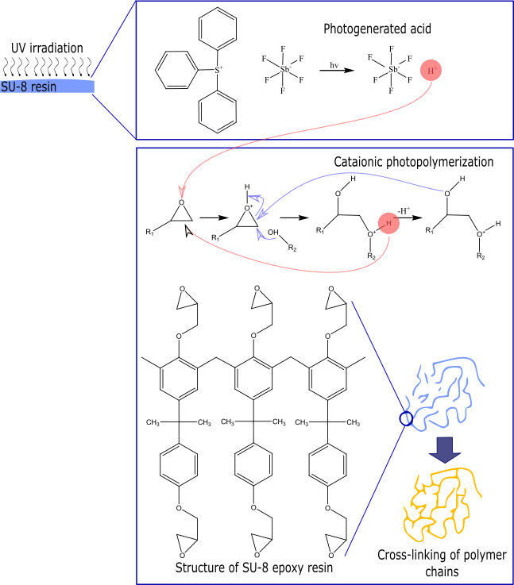
Fig. 1. Cationic photocrosslinking of SU-8 on exposure to UV light

On the other hand, literature suggest that the electrical conductivity of carbon electrodes is enhanced with the execution of mechanical treatments, as the precursor polymer chains align within the fibers. Recent efforts [6, 7] report carbon fibers with superior electrical conductivity, where the polymer chains are aligned with the aid of carbon nanotubes and hydro-electromechanical strain via electrospinning processes.
The aim of this paper was to evaluate the effect of mechanical compressive treatment on electrical conductivity of SU-8 sheets.
.

- Materials and Methods
In regarding to investigate the effect of the mechanical compressive treatment, the compressed sample was fabricated as the following steps (Figure 2). The SU-8 (2100, MicroChem, USA) was casted and its solvent evaporated by increasing the hotplate temperature to 75 °C for 4h. In the following the pre-heated SU-8 sheet was compressed by applying a compressive force about 20KN for 30minutes. The compressed sample quickly underwent the UV exposure and subsequently pyrolyzed at 1000 °C under N2 atmosphere. The control sample was fabricated without applying the mechanical compressive force. X-ray diffraction (XRD) pattern for samples was recorded over a 2θ in the range of 5-55° using a (Model) equipped with the Cu Kα radiation source. The Raman studies was carried out using a Bruker Raman microscope spectrometer equipped with a 532 nm laser. The Raman maps and the averaged Raman spectra were collected across 5µm-5 µm areas of samples. The conductivity of samples, was measured using a four-point-probe. In this method four probes are located in contact with the sheet sample surface. The current is applied through the sample from the outer two probes and thereby the voltage drop is measured by the inner two probes [8]. In very thin sheet samples the resistivity is calculated using the following equation (1):
(1)

Where, V is the voltage, I is the applied current, and t is the thickness of the thin sample sheet.

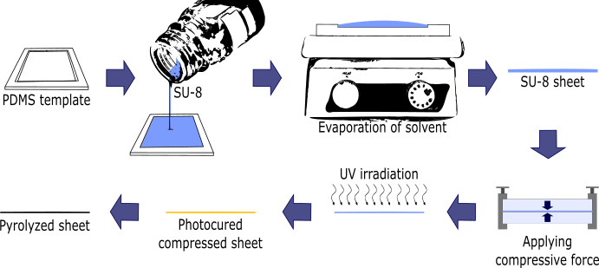
Fig. 2. Schematic diagram of the fabrication process for samples

- Results and discussion
Conductivity measurement is known as a very efficient method regarding evaluation the extent of graphitization and thereby measuring the resistance. In this regards the conductivity of samples was measured using a four-point-probe. Figure 3 shows the average conductivity of samples and accordingly there is no significant differences between the conductivity of two samples. This result shows that the mechanical compressive treatment does not significantly affect the conductivity.
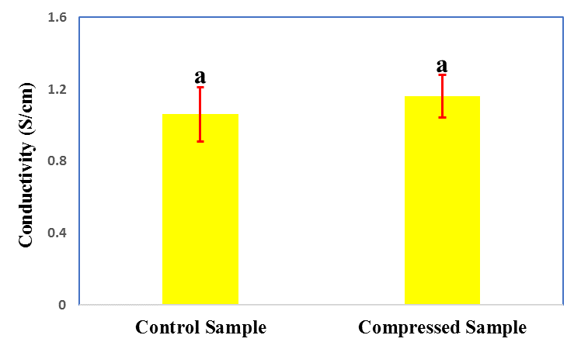

Fig. 3. Average conductivity of samples, according to the analysis of variances, the difference between quantities with similar superscripts(a) is not significant (p > 0.05).

The uniformity of graphitization microstructures can be evaluated by Raman Spectroscopy. Figure 4 shows the average Raman spectra of different samples. There are two characteristic peaks at 1367 and 1606 cm⁻¹ which respectively assigned with D and G. The G peak arises from the stretching motion of the sp²-hybridized carbon-carbon bond in graphitic materials and D peak corresponds to the disorder structure. In this regard, the intensity ration of D peak to G peak is used for evaluation the quality of graphitization. Hence, the higher the D to G ratio is related to the lower alignment of graphitic planes and thereby lower degree of graphitization in the carbon structure [9]. As it can be seen in Figure 4, the intensity of peaks is the same and it means that the mechanical compressive treatment does not change the graphitization microstructure. Furthermore, the mapping Raman Spectroscopy is depicted in Figure and shows the uniform mapping for two samples. This uniformity corresponds to the uniform graphitization microstructures of samples.

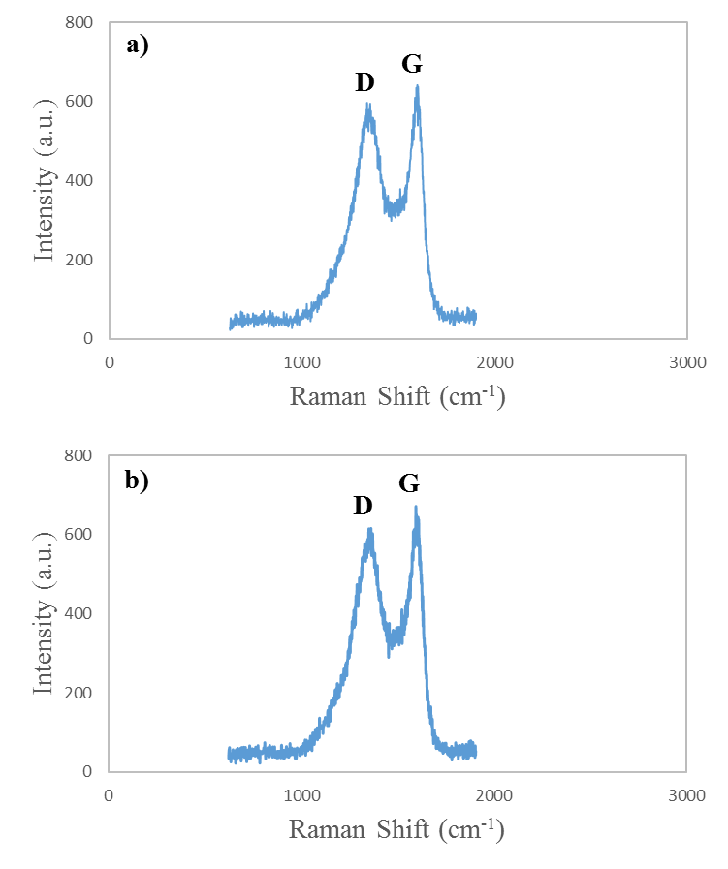
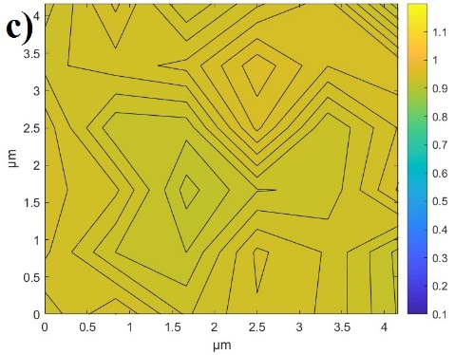
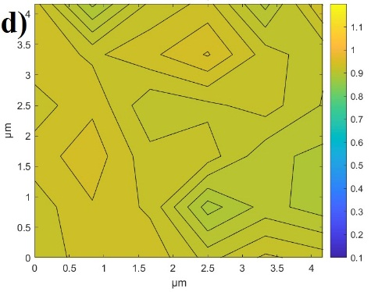

Figure 4: Average Raman spectrum of a) Control Sample and b) Compressed Sample. Mapping of Raman spectroscopy of c) Control Sample and d) Compressed Sample.

We also carried out XRD analysis to evaluate the crystalline microstructure. The results are shown in Figure 5 and two broad diffraction peaks can be observed in both the samples, in 22° and 55°. The broad band at 22° and 55 are related to (002) plane and (100) plane respectively [10]. The broadness of these peaks imply the poor stacking of graphene layers in (002) and (100) plane.

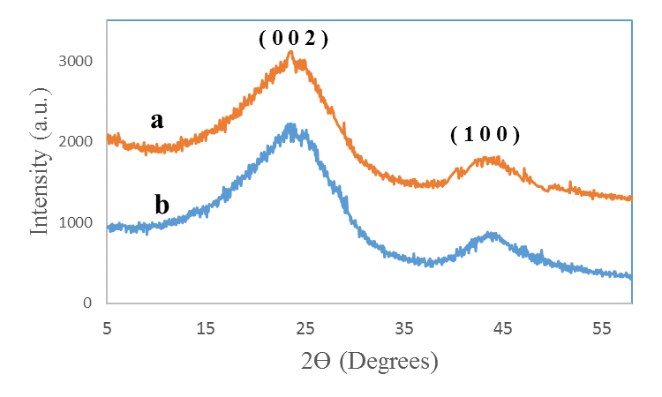

Figure 5: X-Ray diffraction pattern for a) Control Sample and b) Compressed Sample

Nomenclature
PDMS Polydimethylsiloxane
UV Ultraviolet
Acknowledgements
Acknowledgements and Reference heading should be left justified, bold, with the first letter capitalized but have no numbers. Text below continues as normal.

References
[1] R. L. McCreery, Advanced Carbon Electrode Materials for Molecular Electrochemistry, Chemical Re- views 108 (7) (2008) 2646–2687.
[2] B. Cardenas-Benitez, C. Eschenbaum, D. Mager, J. G. Korvink, M. J. Madou, U. Lemmer, I. D. Leon, S. O. Martinez-Chapa, Pyrolysis-induced shrinking of three-dimensional structures fabricated by two- photon polymerization: experiment and theoretical model, Microsystems {&amp;} Nanoengineering 5 (1) (2019).
[3] B. Y. Park, L. Taherabadi, C. Wang, J. Zoval, M. J. Madou, Electrical Properties and Shrinkage of Carbonized Photoresist Films and the Implications for Carbon Microelectromechanical Systems Devices in Conductive Media, Journal of The Electrochemical Society 152 (12) (2005) 136.
[4] G. Canton, T. Do, L. Kulinsky, M. Madou, Improved conductivity of suspended carbon fibers through integration of C-MEMS and Electro-Mechanical Spinning technologies, Carbon 71 (2014) 338–342.
[5] Ghazinejad M, Holmberg S, Pilloni O, Oropeza-Ramos L, Madou M. Graphitizing non-graphitizable carbons by stress-induced routes. Scientific reports 7 (2017) 1-10.
[6] S. Holmberg, M. Ghazinejad, E. Cho, D. George, B. Pollack, A. Perebikovsky, R. Ragan, M. Madou, Stress-activated pyrolytic carbon nanofibers for electrochemical platforms, Electrochimica Acta 290 (2018) 639–648.
[7] M. Ghazinejad, S. Holmberg, O. Pilloni, L. Oropeza-Ramos, M. Madou, Graphitizing Non-graphitizable Carbons by Stress-induced Routes, Scientific Reports 7 (1) (2017) 16551. doi:10.1038/s41598-017-16424- z.
[8] Xue B, Zou Y, Yang Y. A photochemical approach for preparing graphene and fabrication of SU-8/graphene composite conductive micropatterns. Materials & Design 132 (2017) 505-11.
[9] Hassan YM, Caviglia C, Hemanth S, Mackenzie D, Alstrøm TS, Petersen DH, et al. High temperature SU-8 pyrolysis for fabrication of carbon electrodes. Journal of Analytical and Applied Pyrolysis 125 (2017) 91-9.
[10] Mamidi S, Kakunuri M, Sharma CS. Fabrication of SU-8 Derived Three-Dimensional Carbon Microelectrodes as High Capacity Anodes for Lithium-Ion Batteries. ECS Transactions 85 (2018) 21-7.

Instructions to Authors for Word template
1. Locking of Copyright:
The copyright line is locked in the templates. The author may not edit the same and making it editable only PSMs. If there are any copyright changes required, you are requested to contact Journal Manager through Guest Editors. For editable the below mentioned steps must be followed:

Steps:
- Click on copyright statement
- Click on Properties in Developer tab
- Remove the checks from Content control cannot be deleted and Contents cannot be edited under Locking and then Press ok
2. Docm format:
We have added macros in the Word templates for the below mentioned features. And since macros are not supported in doc and docx format we created the templates of all titles in .docm format.

- Removal of all highlights
- Accept track change
- Locking of Rules

If .docm format needs to convert in docx format then the following steps must be performed:

Steps:
- Press Alt F11
- Click on Project (JID_Template)
- Enter "thomson" in Project Password
- Click on Microsoft Word Objects
- Click on ThisDocument under Microsoft Word Objects
- Delete all macros under General
- After deletion close the Code and Project (JID_Template) windows
- From File menu click on save as type .docx option
3. Comments added in the margin in Word master templates:
There are instances where author raising queries on what to do with key information lines such as “volume, page numbers”, “Conference title per issue” and “Copyright entity, year, copyright company Elsevier Ltd./B.V./Inc. and Organizer Name” in the copyright statement and for these concerns the comments have been inserted in the Word template to guide Author/JM about the information to be inserted by them in these fields.
Comments removal from Print: In Word 2007 and 2010 the comments present in a document get printed by default. If the authors do not want to get the comments appearing in print, the authors must remove the comments from the Word template before printing by changing the Print markup setting of word using the following steps:
Steps:
- Click the File tab
- Click Print
- Under Settings, click the arrow next to Print All Pages
- Click Print Markup to clear the check mark
Instructions to Authors pages to be excluded from Print:
- Click the File tab
- Click Print
- Under Setting, Type page numbers and/or page ranges separated by commas counting from the start of the document or the section. For example, type 1, 3, 1-5
4. PDF creation from Word master template:
While creating PDF from Word template the below given steps should be followed to avoid difference in trim size and margins and to avoid decrease in resolution and size of the figure images of the Word template and the PDF created.

Steps in Word 2007 and 2010:
- Click the File tab
- Click Print
- Under Printer tab, select Adobe PDF
- Click Printer Properties link
- Under Adobe PDF Settings tab, click on Edit button
- Click on Images folder under Standard
- Make Downsample and Compression fields under Color Images and Grayscale Images "Off". And in Monochrome Images field make only Downsample "Off'
- Then click on OK and given name of the setting in File name tab and click on save
- Then again Under Adobe PDF Settings tab, click on Edit button
- Then click on Color folder
- Choose Leave Color Unchanged option under Color Management Policies tab then click on OK
- Lastly click on OK in Adobe PDF Settings tab
- Click Save As
- Under Save as type, click the arrow next to PDF (*.pdf)
- Click Save

In Word 2003 the PDF can be created by using “Convert to Adobe PDF” symbol in tool bar or the required paper size can be adjusted in the Adobe PDF settings given in the Properties tab on the Print option. Please follow the above steps to avoid decrease in resolution and size of the figure images.
5. Reference styles used in the master templates:
Title Reference style
AASPRO 2 Harvard
AASRI Procedia 3 Vancouver Numbered
APCBEE Procedia 3 Vancouver Numbered
EGYPRO 3 Vancouver Numbered
FINE 2 Harvard
IERI Procedia 3 Vancouver Numbered
MATPR 1a Numbered without article titles
MSPRO 2 Harvard
PHPRO 2 Harvard
PIUTAM 3a Embellished Vancouver
Procedia CIRP 3 Vancouver Numbered
PROCHE 3a Embellished Vancouver
PROCS 3a Embellished Vancouver
PROENG 1 Numbered
PROENV 3a Embellished Vancouver
PROEPS 3a Embellished Vancouver
PROFOO 3a Embellished Vancouver
PROMFG 1a Numbered without article titles
PROTCY 3 Vancouver Numbered
PROVAC 3a Embellished Vancouver
SBSPRO 5 APA
SEPRO 3a Embellished Vancouver
AQPRO 2 Harvard
UMKPRO 5 APA

